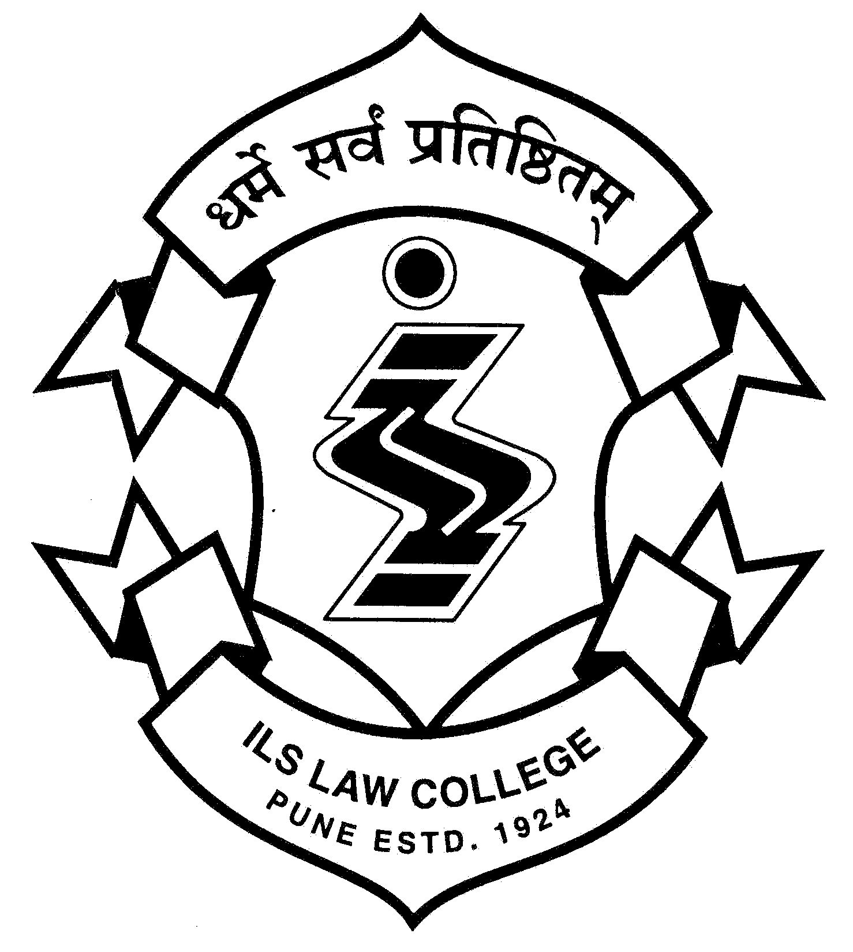  ®  ILS | ILS Law College  Law College Road, Pune 411 004  Tel: 020-25656775, 020-25656780  email: ilslaw@ilslaw.in, web: www.ilslaw.edu  (accredited A+ level by NAAC (2004-2009)
12/09/2018
Notice
I BA LL.B. - CAP Round 4
At the end of CAP Round III 35 seats are vacant at ILS Law College Pune. The College will accept off line application form for vacant CAP seats from 18th September 2018 to 25th September 2018 on all official working days. Sample application form for admission at CAP Round IV to be downloaded by the candidate from the CET Cell Website http://www.mah-llb5admission.in

ILS Law College – Vacancy for admission in CAP IV
Category | Vacancy
Open (Outside Maharashtra) – Male / Female | 4
Open (Within Maharahstra) – Male / Female | 12
Open (Within Maharashtra) – Female | 3
SC – Female | 2
ST – Male / Female | 8
ST – Female | 2
VJNT – Male/Female | 1
OBC – Female | 2
OBC – Male / Female | 1
Total | 35

Documents to be enclosed along with the Application Form.
- Self-Attested Photo Copy of CET Score Card.
- Self-Attested Photo Copy of CAP Application Form.
- Self-Attested Photo Copy of SSC Certificate/ Marks Memo.
- Self-Attested Photo Copy of HSC Marks Memo/Certificate.
- Self-Attested Photo Copy of Caste Certificate.
- Self-Attested Photo Copy of Caste Validity Certificate.
- Self- Attested Photo Copy of Non- Creamy Layer Certificate.

# Strike off whichever is not required.
- XI Marks Memo is Optional.
Candidates are required to submit application form in duplicate for acknowledgement of receipt in college office timing between 10.00 am to 3.00 pm.

Please refer to Notice No. 8 published on the CET Cell Website http://www.mah-llb5admission.in

(Vaijayanti Joshi)
Principal

