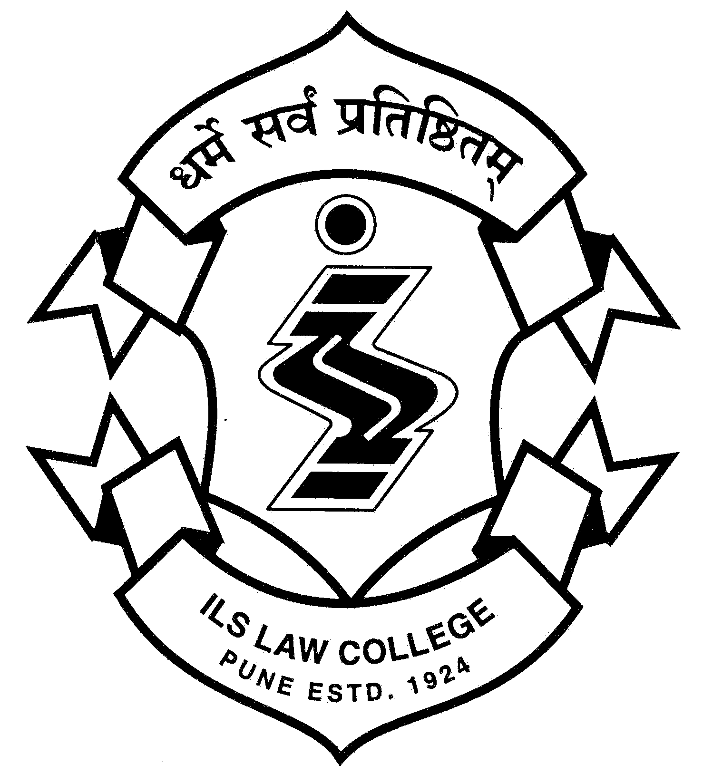  ®  ILS | ILS Law College  Law College Road, Pune 411 004  Tel: 020-25656775, 020-25656780  email: ilslaw@vsnl.com, web: www.ilslaw.edu  (accredited A+ level by NAAC (2004-2009)
Admissions 2016-17
First Year of the Five Year and Three Year Law Course
Round – VI

Institutional Admission Round

General

- The candidate, who are seeking Admissions at ILS Law College should follow below mentioned schedule :
Dates | Particulars
29/10/2016 to 02/11/2016 | Online Application by the Candidates for seeking admissions in CAP Round VI on DHE Website :  http://llb3.mhpravesh.in  http;//llb5.mhpravesh.in
02/11/2016 at 5 PM | Display of vacancies on College Website
02/11/2016 to 05/11/2016 Till 12 Noon | Candidates are required to submit application Form in the Prescribed Format in College Administrative Office
05/11/2016 at 5 PM | College will display Merit List
08/11/2016 to 09/11/2016 | Candidates should Report to college whose name appeared in The College Merit List & Complete Admission Process as per Instructions given below.

- The candidate must bring all original documents for scrutiny for the purpose of admission. Those Candidates who have secured admission in any other colleges in any of previous CET rounds must cancel their admissions. The Candidate is required to carry the following documents for Securing Admissions in CAP Round VI

Documents

You must bring the ORIGINAL documents along with one set of self-attested copies (all documents) as per the Information Brochure for admission to Higher Education Courses and notification dated 20th Sept 2016 at the time of CAP Round 3.
Candidate should bring Original Transfer Certificate/Leaving Certificate/Migration Certificate (if required), XI Mark sheet, Gap Certificate (Original) if required.
The brochure, Pro Formas and notifications issued by the Directorate of Higher Education are available at:

http://llb5.mhpravesh.in/StaticPages/HomePage.aspx or http://llb3.mhpravesh.in/StaticPages/HomePage.aspx

- The College will not admit the candidate if,
  - he / she does not personally attend the process
  - he / she does not bring original documents for our scrutiny at the time of admission process, or
  - his / her documents are not complete, or
  - he / she does not pay fees immediately by way or demand draft, or
  - he / she does not complete other formalities, or
  - he / she is not eligible under the rules and provisions applicable to admissions
- The candidate must complete the admission procedure within prescribed time limit given in the schedule.
- No other person is authorized to grant or to promise or to make any representation regarding admissions.
- All admissions are provisional and subject to further approval by the Savitribai Phule Pune University.

IMPORTANT NOTE:

- The candidate is NOT eligible for admission if he / she does not possess allotment letter.

- Candidate must bring a soft copy of his / her recent photograph of size between 20 KB and 100 KB in JPEG format.

- The candidates will be given eight days’ time to submit their original documents. However, they will have to produce original fee receipt of the college where they have taken admission.

- Those Students who have confirmed their admissions in ILS Law College and submitted undertaking regarding Certificate of Nationality should produce the Nationality Certificate (Original) along with attested photocopy within 3 months from the date of their admission.
- ST Category candidates who have appeared for CET LAW and have valid Caste Certificate but do not have Caste Validity and are yet to apply for the Caste Validity will be admitted provisionally by the colleges. The candidate will have to submit an undertaking on Rs.100/-Stamp Paper to the effect that he/she will apply for caste validity through Principal of the admitted College and submit the Caste Validity within One Year from the date of admission to the college failing which he/she will be liable for action as per the provisions in the relevant circulars of the Tribal Development Department.

College Admission Fees:
The candidate must pay full fees either by Demand Draft of any nationalized bank drawn in the name of ‘Principal, ILS Law College, Pune’ payable at Pune. The amount of fees is as follows:

Category | I BA LL.B. and I LL.B.  Amount (Rs)
Within Maharashtra State -Open  (including physically handicapped category) | 36,940/- + Rs.1000 as Seat Acceptance Fee/ Processing Charges =37940/-
Reserved Category - SC/ NT/ SBC/ OBC | 33,455/- + Rs.1000 as Seat Acceptance Fee/ Processing Charges =34,455/-
Reserved Category – ST | 0/-+ Rs.1000 as Seat Acceptance Fee/ Processing Charges = 1000/-
Outside Maharashtra State  (including physically handicapped category) | 38,940/- + Rs.1000 as Seat Acceptance Fee/ Processing Charges = 39,940/-
PIO / SAARC / GULF | 1,09,140/- + Rs.1000 as Seat Acceptance Fee/ Processing Charges = 1,10,140/-
NRI | 1,81,900/- + Rs.1000 as Seat Acceptance Fee/ Processing Charges = 1,82,900/-

- The candidate shall pay any increase in fees, if increased during the academic year under any rules, orders or directions given by the State Government, Pune University, or other authorities.
- If a candidate cancels the admission, the College will refund fees according to rules of the Pune University. In any case, there is no refund of fees if you cancel admission thirty days from your admission.

Lectures
Lectures have already commenced. Students are advised to join the college and attend lectures immediately from the very next day of their admission. The attendance of the students admitted in the 6th round will be recorded from 10th Nov 2016.
Minimum 75% attendance is mandatory for grant of the term.

